Nama : Catur Mukti Andriyanti
NIM : 23.01.55.7007

TUGAS WEB SERVICE MENGGUNAKAN POSTMAN

- Daftar Customers
http://localhost/php-crud-api/api.php/records/customers
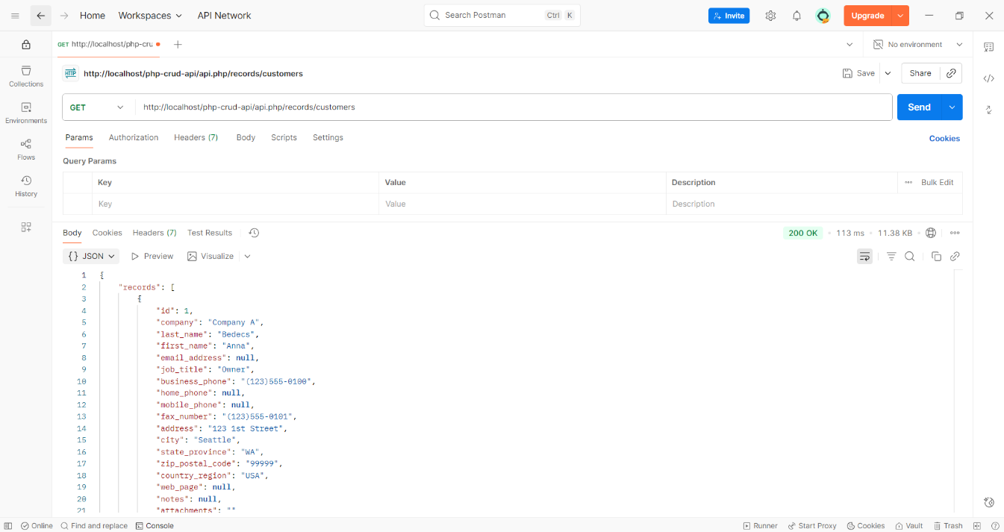

- Detail Customers
http://localhost/php-crud-api/api.php/records/customers/5
